Homework 8 STAT:3210 Experimental Design and Analysis

Yubing Li 00808366

**1. Problem 6.20:**

(a) The experiment is **23 factorial** designed. The treatment factors are **quantitative**.

There are **2 replicates** for each combination.

(b) $H_{o}: β_{11}=…=β_{33}=0 vs H_{a}: β_{ij}≠0$ for at least one i, j

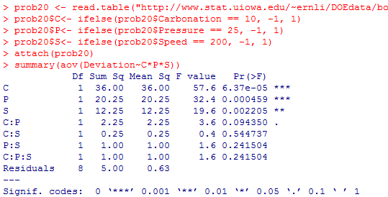

Since the p-value for **C, P, S, and C:P** are smaller than 0.1, we reject the H0 and conclude they are significant to height deviation. C:P is marginally significant.

(c) 1) Main effect:

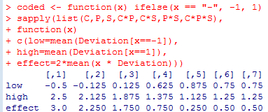

2) (R output is on the next page)

3) Since the **effects are just twice the regression coefficients**, the results are coincide.

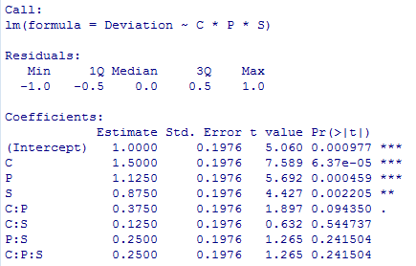

(d) **C, P, S, and C:P** are important effects. It’s **consistent** with the result of the ANOVA.

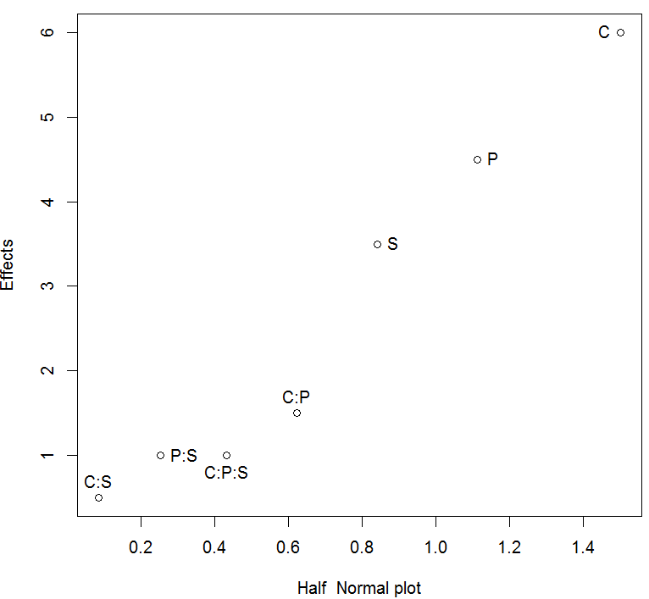

(e) 1) In the reduced model, the C, P and S are important factors at level = 0.05.

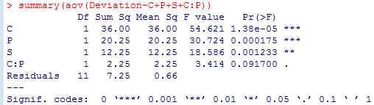

2) Fitted model: $\hat{y}=1+1.5x_{Carbon}+1.125x_{Pressure}+0.875x_{Speed}+0.375x_{Carbon}x_{Pressure}$

Where Xc, Xp are ±1 for high and low C, P.

The **coefficients are the same** as those in full model.

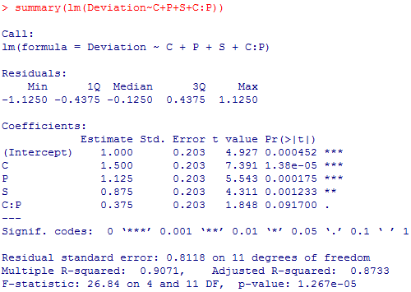

3) The factorC :factorP: factorS line is interpreted as lack of fit, since it’s not significant, we conclude there’s **no lack of fit**.

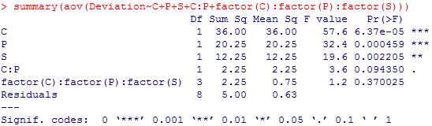

4) The residual plots don’t show any strong patterns against the assumptions. Therefore we consider the normal assumption and constant variance assumption are not violated.

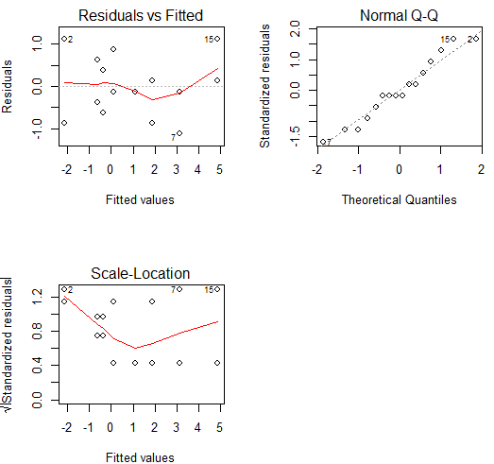

**2. Problem 6.22:**

(a) The experiment is **24 factorial** designed. The treatment factors are **quantitative**.

There is only **1 replicate** for each combination.

(b) Since the design is unreplicated, the degree of freedom for pure error will be 0. We may not conduct an ANOVA with p-values.

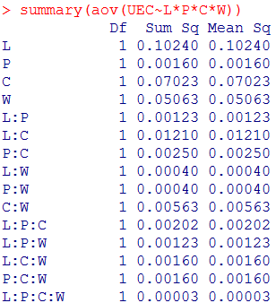

(c) $H_{o}: \sum{β_{11}+…+β_{44}=0} vs H_{a}: \sum{β_{ij}}≠0$ for at least one i, j

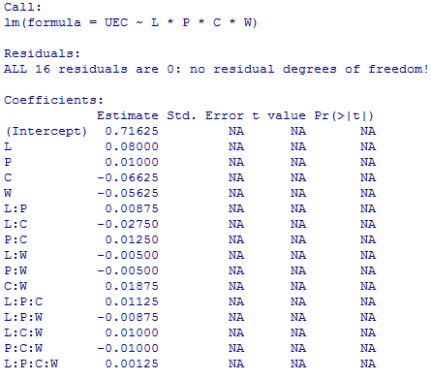

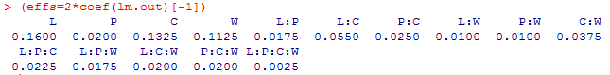

(d) 1) The **L, C, W, L:C** are important effects.

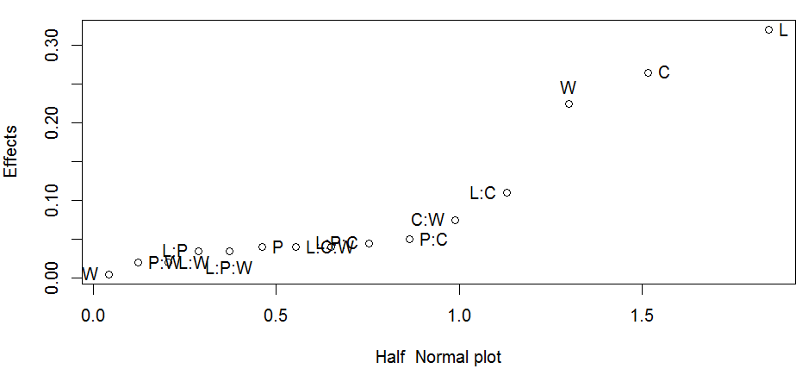

2) From the PSE method, we notice that L, P, L:P are the important effects for UEC.

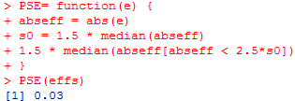

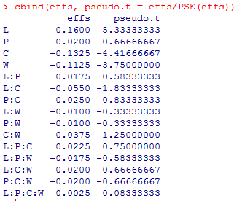

The pse t-value for **L, C, W** are larger, which means they are more important.

3) The outcomes are **consistent**.

(e) 1) Yes, since P is not very important to UEC, we ignore the pressure (P) so as to **conduct a 23 factorial design with replicates**.

2) Since the p-value for **L, C, W , L:C** are small, we conclude they are significant for UEC.

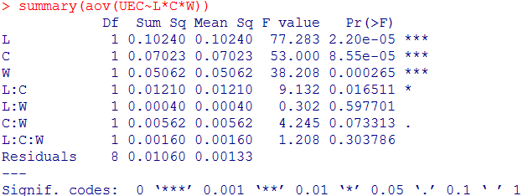

3) Fitted model:

$$\hat{y}=0.7163+0.08x_{L}-0.0663x_{C}-0.0563x_{W}-0.0275x_{L}x_{C}+0.01875x_{C}x_{W}$$

Where Xl, Xc, Xw are ±1 for high and low L, C, W.

Yes, the estimated coefficients are the **same**.

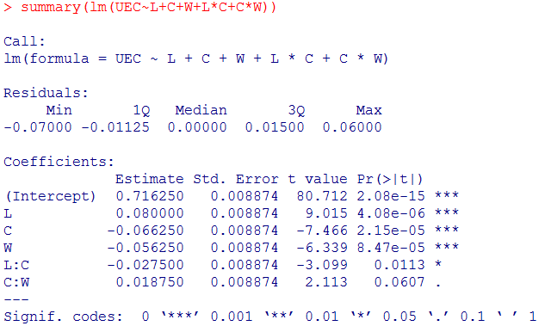

**3. Problem 6.23:**

(a) The experiment is an **extending** **24 factorial** designed. The treatment factors are **quantitative**. There is only **1 replicate** for each combination.

Yes, there’re **4 center points**.

(b) 1) The **estimated effects are the same as** previous one.

not H0

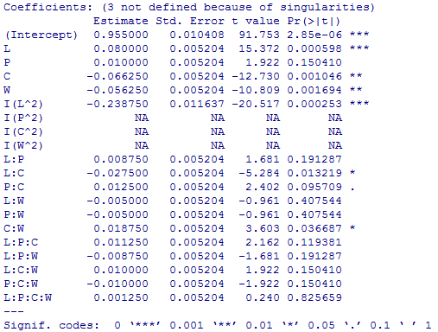

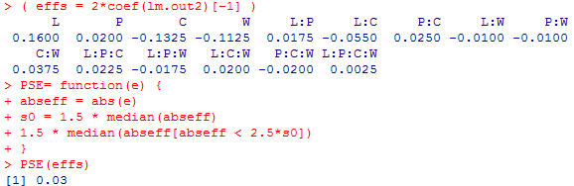

Since the p-value for L, C, W and L:C, C:W are significant to UEC.

The estimates of the effects are consistent with the original 24 factorial experiment.

2) The L, C, W and L:C are relatively important effects.

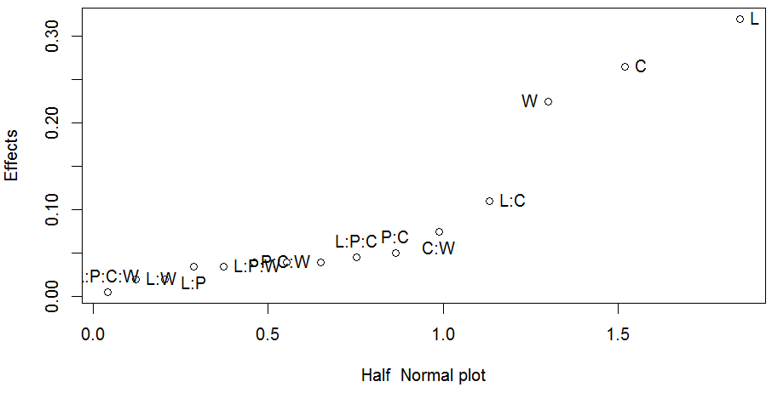

3) The pse t-value for **L, C, W** are larger, which means they are more important.



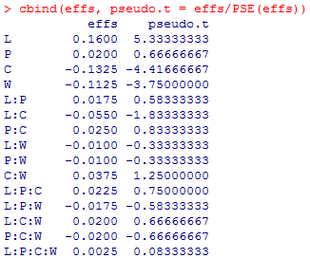

4) The results are the **same**.

(c) not H0

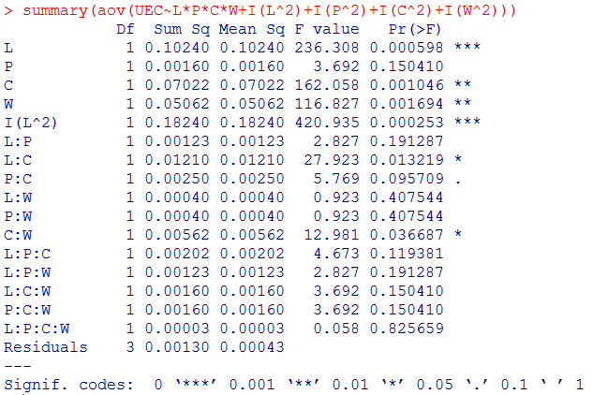

Since the p-value for **L, C, W, I(L^2) and L:C, C:W** are significant to UEC.

The estimates of the effects **are consistent with** the original 24 factorial experiment.

(d) H0: the reduced model is sufficient vs Ha: not H0

The p-values are small, we reject the null hypothesis and conclude they are significant factors.

The factor:… line is interpreted as lack of fit, since it’s not significant, we conclude there’s **no lack of fit**. The residual is now pure error with 4 center points.

